Source https://www.viator.com/tours/Honolulu/Royal-Crown-of-Oahu-60-Min-Helicopter-Tour/d59070-28456P1
__________________________________________________________

Oahu Royal Crown Helicopter Experience: 60-Minute Scenic Flight
__________________________________________________________
★★★★★ 4.5/5 20 reviews

Add to wishlist ♡

__________________________________________________________

1 Hour | €460 per person

🏕  Image | 🏕  Image | 🏕  Image | 🏕  Image | 🏕  Image | 🏕  Image

__________________________________________________________
Experience Overview
Take to the skies for an unforgettable aerial adventure above Oahu’s most celebrated landscapes. This scenic helicopter journey showcases the island’s dramatic coastlines, volcanic formations, legendary beaches, and historic landmarks from a breathtaking bird’s-eye perspective. With flexible departure times and the choice between doors-on or doors-off flights, the experience can be tailored to your preferred level of thrill and comfort while delivering panoramic views few travelers ever see.
__________________________________________________________
Tour Snapshot
- Duration: Approx. 60 minutes flight time
- Meeting Point: Rainbow Helicopters, 155 Kapalulu Pl #197, Honolulu (Castle & Cooke Aviation Building)
- Group Size: Shared or private flight options available
- Accommodation: Not included (flight experience only)
- Languages Available: English
- Private Tour: Optional private upgrade available
- Transportation: Not included (self-arrival required)
- Season: Available year-round
__________________________________________________________

Check Dates & Availability

Select participants: (Age 99 and younger) - 1 +

Choose date:
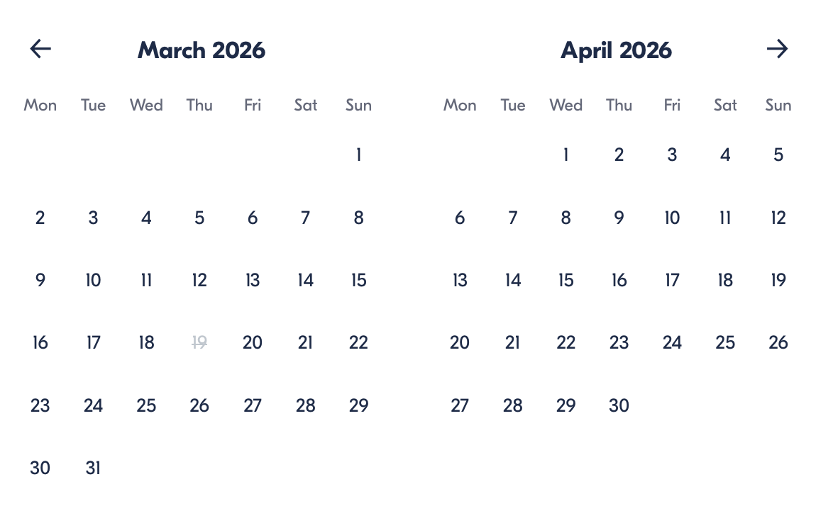

Check Availability

opens:

Participants: 1 March 16, 2026

Oahu Royal Crown Helicopter Experience: 60-Minute Scenic Flight
- Duration: 1 hour
- Offered in: English
Departure Times:
9:00 AM · 10:00 AM · 11:00 AM · 12:00 PM · 2:00 PM · 3:00 PM · 4:00 PM · 5:00 PM
Cancellation:
- More than 24 hours before start: Full refund
- Less than 24 hours before start: No refund
Price breakdown: 1 Participant x €460

Total: €460

The total price includes all taxes and fees.

Add to cart Book now

__________________________________________________________
Tour Highlights
- Aerial Island Views: Witness Oahu’s landscapes from above, including coastlines, valleys, and volcanic terrain.
- Iconic Landmarks: Fly past famous sites such as Diamond Head, Hanauma Bay, and Pearl Harbor.
- Thrill Option: Choose between open-door or closed-door flight experiences.
- North Shore Views: Observe legendary surf breaks and scenic beaches from the sky.
- Custom Timing: Multiple departure times allow you to fit the flight into your schedule.
__________________________________________________________
Flight Experience Route
Departure — Honolulu Airport Base
Arrive at the helicopter terminal, check in, and choose your preferred seating and door configuration before takeoff.

Waikiki Skyline & Diamond Head
Lift off above Honolulu’s skyline and glide past Waikiki Beach before circling the volcanic crater of Diamond Head.

Coastal Cliffs & Nature Reserves
Fly along the island’s southeastern shoreline over Hanauma Bay and Makapuu Lighthouse while admiring dramatic lava cliffs and ocean scenery.

Windward Coast & Valleys
Soar above Lanikai Beach, Mokoliʻi Island, and the lush Kaʻaʻawa Valley surrounded by emerald mountains.

North Shore & Plantations
Observe surfers riding powerful waves along the North Shore and pass above the famous Dole Plantation fields.

Historic Finale — Pearl Harbor
Conclude the journey with a respectful aerial pass over Pearl Harbor and the USS Arizona Memorial before returning to base.
__________________________________________________________
Included in Price
- Helicopter flight experience
- Parking fees at the departure location
- Safety phone strap
__________________________________________________________
Not Included
- Gratuities for the pilot or staff
- Transportation to the departure location
__________________________________________________________
Not Suitable For
- Passengers under the required weight minimum for doors-off flights
- Travelers exceeding aircraft weight limits
- Individuals under 24 months without a seat purchase
- Passengers who appear intoxicated at check-in
__________________________________________________________
Important Flight Information
- Weight Requirements: Maximum passenger weight is 280 lbs. Additional balance fees may apply to guests weighing more than 260 lbs.
- Safety Policy: Operators may refuse boarding for safety reasons, including intoxication.
- Age Policy: All travelers aged 24 months and older must purchase a full seat.
- Confirmation: Booking confirmation is issued immediately upon reservation.
- Weather Conditions: Flights operate only in suitable weather; rescheduling or refund is offered if conditions prevent departure.
__________________________________________________________

Cancellation Policy
Free cancellation up to 24 hours before departure.
- Cancellations within 24 hours are non-refundable.
- Changes requested less than 24 hours prior cannot be processed.
Weather or minimum-passenger cancellations qualify for rescheduling or a full refund.
__________________________________________________________
What Our Clients Are Saying

Overall rating  4.5/5  ★★★★★  Based on 20 reviews | Review summary  Guide 4.5/5  Transportation 4.6/5  Service 4.7/5  Organisation 4.5/5

Filter  - All traveller types  - Couples  - Group of friends  - Families  By star rating  - All star ratings  - 5 stars  - 4 stars  - 3 stars  - 2 stars  - 1 star | Search reviews (e.g., guide)  Sort by:  - Top picks  - Latest reviews  - Best ratings  - Lowest ratings
__________________________________________________________
★★★★★
Luis M. — Mexico
Absolutely breathtaking views from start to finish. Seeing Oahu from above completely changed our perspective of the island.
★★★★★
Clara N. — France
An incredible flight experience. The scenery was stunning and the pilot made the journey both informative and exciting.
★★★★☆
Jonas K. — Sweden
Fantastic aerial tour with amazing photo opportunities. I only wish the flight lasted a little longer.
See more reviews
__________________________________________________________

Meta tags

Page - Oahu Royal Crown Helicopter Experience: 60-Minute Scenic Flight

Title: Oahu Royal Crown Helicopter Experience: 60-Minute Scenic Flight | Travellio Global

Description: Enjoy a 60-minute helicopter flight over Oahu’s most iconic landmarks, including Diamond Head, North Shore, and Pearl Harbor, with panoramic island views.

H1 - Oahu Royal Crown Helicopter Experience: 60-Minute Scenic Flight
__________________________________________________________

